Ⅰ．Member Profile
Organization：Ja-DHRRA |  | Year Established 1974
Office Address：
842 Banchi Nakanoma Yachiyo-ku, Taka-cho, Taka gun, Hyogo Pref., 677-0121 Japan
Telephone Number: +81-90-8888-7447 | Fax Number: +81-775-37-1161
E-mail address: fujioka@econ.kobe-u.ac.jp | Website: http://ja-dhrra.jimdo.com/
Executive Director (Representative, Contact Person ) Yoshihide Fujioka

Ⅱ．DHRRA Report(2012-2014 Highlight of Operations / Performance)

Ⅰ．Ja-DHRRA’s Profile
At the beginning,
In December 2012, Ja-DHRRA’s Representative were changed from Dr. Yatani to Fujioka.
I am Fujioka, a professor of Kobe-University, belonging to Faculty of Economics. My research field is Social Security System, in specially Social Insurance and Social Welfare.
Now. I want to show you a few episodes to introduce myself. And that will explain the reasons why I begin Ja-DHRRA’s Activities.

Ⅱ. Japanese Economic Society
Here, I easily explain the Japanese society situation
(1) Japanese Social Issues
The Japanese people are indeed satisfied in terms of “material wealth,” but on the other hand, we are facing social issues which are ageing, depopulation(decreasing population), declining birthrate and “Income Gaps and Social Unrest” coursed by Money‐Market Speculation.
In particular, Japanese are facing the Financial Crisis in Social Security System, the Cost of Medical Care Insurance are accelerate increasing. In generally, that is caused by Aging Society. In other words the Expansion of Social Security Cost depend on the increase in elderly person population.
On the other side,
The income gap between rich and poor is widening. Much of young people can’t marriage and they also can't give birth to a child. And Social Income Gap is concern to the increase of suicide. In these 13 years, there are from 27 to 30 thousand suicide every year, Suicide of young people is very social sickness, the most serious problem.
While aging and depopulation have been advancing, there are an increasing number of local communities that have very few youth to cultivate the fields. We call them “Marginal Settlement”, Marginal settlements means the village where 50 percent of the population has reached or exceeded the age of 65 because of depopulation.

(2) In My Research,
However, when I researched local community in Hyogo Prefecture Japan, I saw many elder people who are from 80 to 90 years old. They are very healthy and enjoy the active life through “Family Farming”. Therefore they don’t need much medical services and they don’t want to go to a nursing home in the future. These observation make me to think the meaning of Sociality, Social Relation and Community Organization.
The Quality of Community Life obviously influent to the activities of elder people and their health. If we want to decrease the Medical Care Cost, we should enjoy with the brotherhood and friends in a community. That is the best way to realize a happy life. But then, we must think, “Who is the brotherhood?”, “How can I get the brotherhood?” These are fundamental questions for sociology.
(3) I became an apprentice of Dr.Yatani
Almost 12 years ago, I met Prof.Yatani and knew the Phenomenological Sociology by Kazuta Kurauchi for the first time then. Kazuta Kurauchi is the master of Prof. Yatani.
His academic theory is very difficult to understand, but the essential message is not a difficult thing to apply the theory to practice.
The human being can learn mainly from "a fact of experience ". Therefore it is most important to work with many people work, to find pleasure and to learn from them. Conversely if human becomes lonely, isolated without any social relationship, he will must be in sick and deny himself.
Don’t be afraid of mistake and misunderstanding by other people, we should always try to practice new challenges with friends.
So far, I easily explained the Japanese present conditions.

Ⅲ. Ja-DHRRA’ Mission 2012-2014
Now Ja-DHRRA Members are not so many, Dr.Yatani and some my ex-students (graduates my seminar).
Dr.Yatani and I are working on experiences and practices in nature fields, these are the education for University's students. My ex-students sometimes visit to our practices and support us.

1. Research Activities on Economic Sociology
I am interesting in a Research on Conditions for Sustainable Community and create Original Theory of Community Practice. This is Economic Sociology.
And I will seek the new theory through our practices in Rural Area. So for myself, Ja-DHRRA’s first Purpose is Research Activities.

2. Education for the young people
Japanese students are worried about the future of their own at all times. They say, “Before graduation, can I determine an Employment or not”? It is a concern of their biggest. Even if it is possible to get the job, it is not always possible to continue to work in the company. There is always uncertainty about the future in the eyes of young people.
Therefore we have provided to students the opportunities of the new experience in rural aria which is depend on another Social Value.
That is to say,
(1) Camping in Mountain, (2) Rice Growing, (3) Study Tour in Philippine,
(4) Cultivation of linen and (5) Construction of Log-House.

(1) Camping in Mountain
Dr.Yatani has been continuing the Camping Practice in the Mountain since about 30 years ago. There is no electricity, no gas, no water service, and no restroom. This is the “Wakeo Camp” in Hyogo Prefecture. I have been also participating more 10 years with my students.
Students experience to chop wood and make a fire for the first time in their lives, and cook with water of the river. Wakeo Camp is the staying for 4 nights and 5 days, in a rich natural environment, Students learn many thing how we can survive in a pure nature with friends.
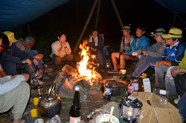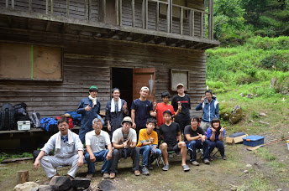
Wakeo Camp, 2014

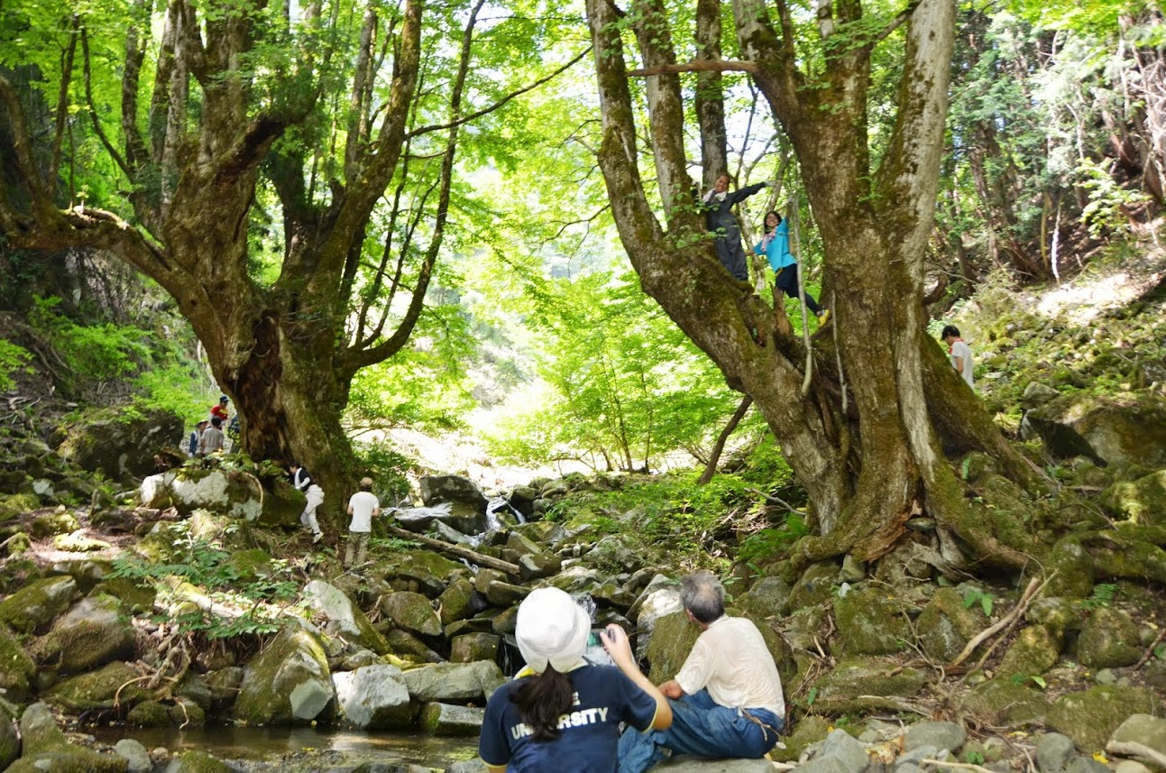
Wakeo Camp, 2013

(2) Rice Growing,
This practice means experience to produce rice, distribution, consumption with friends. Unfortunately, Japanese do not have the experience to enter the paddy fields. Students have been only learning for entrance examination. So Rice Growing also the first experience for young.
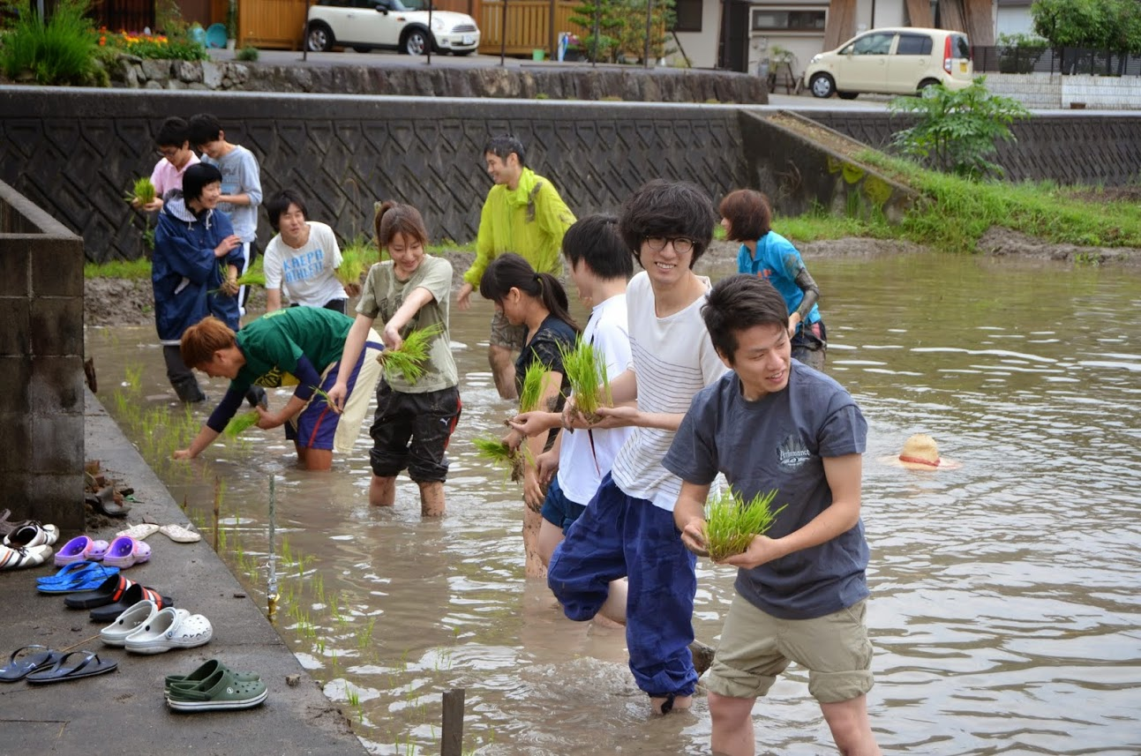
Rice‐Planting, 2014

(3) Study Tour in Philippine
Study Tour in South Asia is the Ja-DHRRA’s main activity. Phil-FHRRA always help us to make the plan and guide us for good study tour. We appreciate Phil-DHRRA very much.
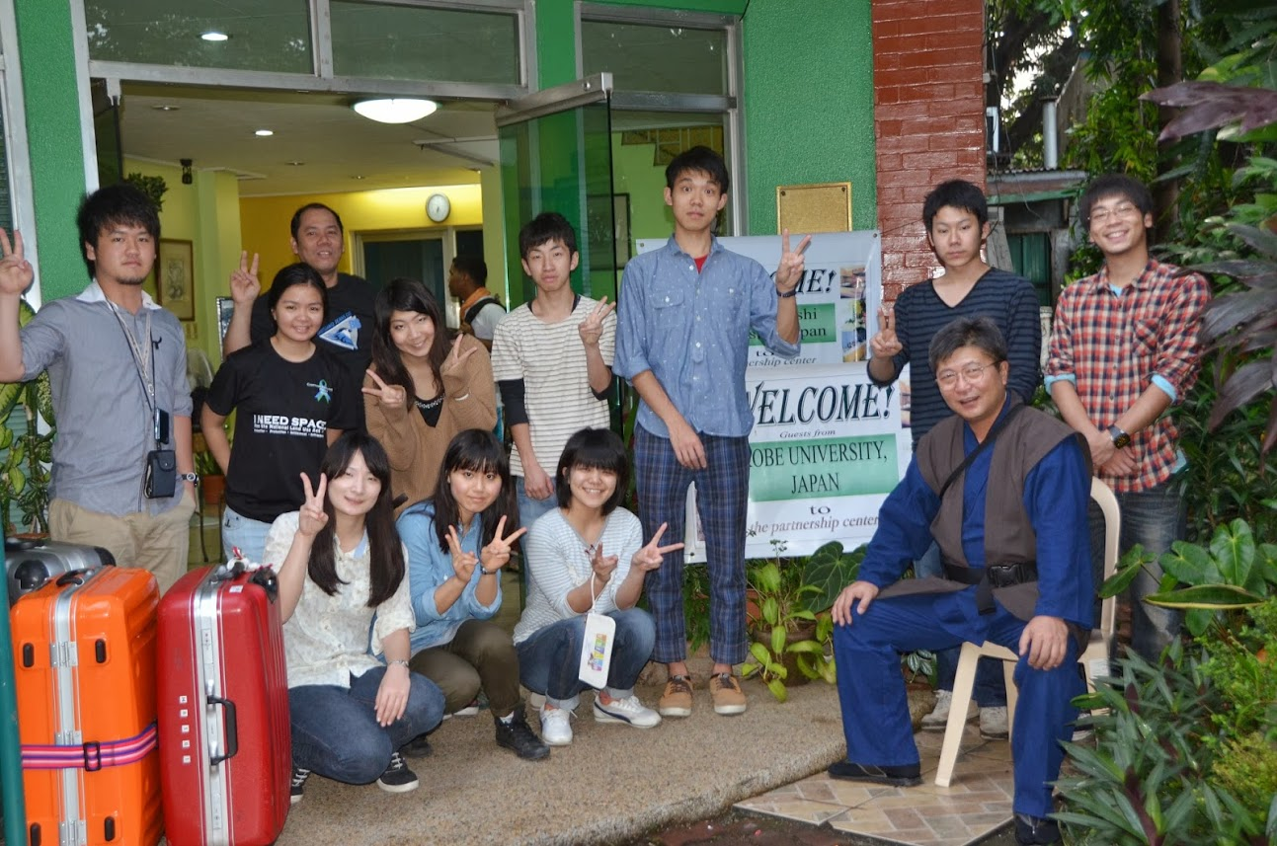
Study Tour in Philippine, 2013

(4) Cultivation of linen and (5) Construction of Log-House
From 2012, we have developed two new activities.
1. In order to supply the linen to the textile company in local community, we began the cultivation of linen along with the local residents. This business is named “ASABAN Project”, ASA means linen in Japanese, BAN is the short name of Banshu district of Hyogo Prefecture. ASABAN has another meaning of “from morning to night” you must work hard.
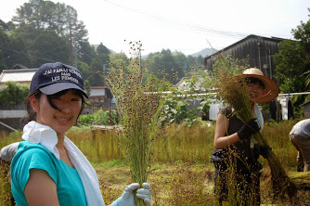
Crop of the linen, 2013
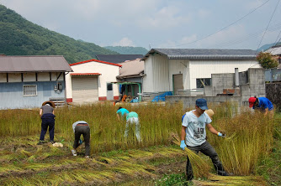
Crop of the linen, 2014

2. Also, in another village, I formed a new student circle “Tree House (in Japanese, KINOIE)”. The purpose is to encourage Community Cooperation and Business through cultivation of oilseed rape. While building a Log House in the mountains of the village, the member of this circle have been contributing to develop the village Corporate Farming Business.
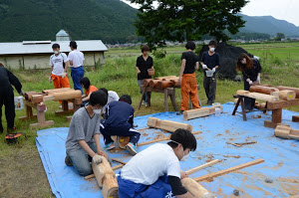 Constructing Log House, July, 2012
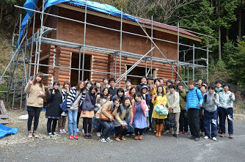Log House, 2013

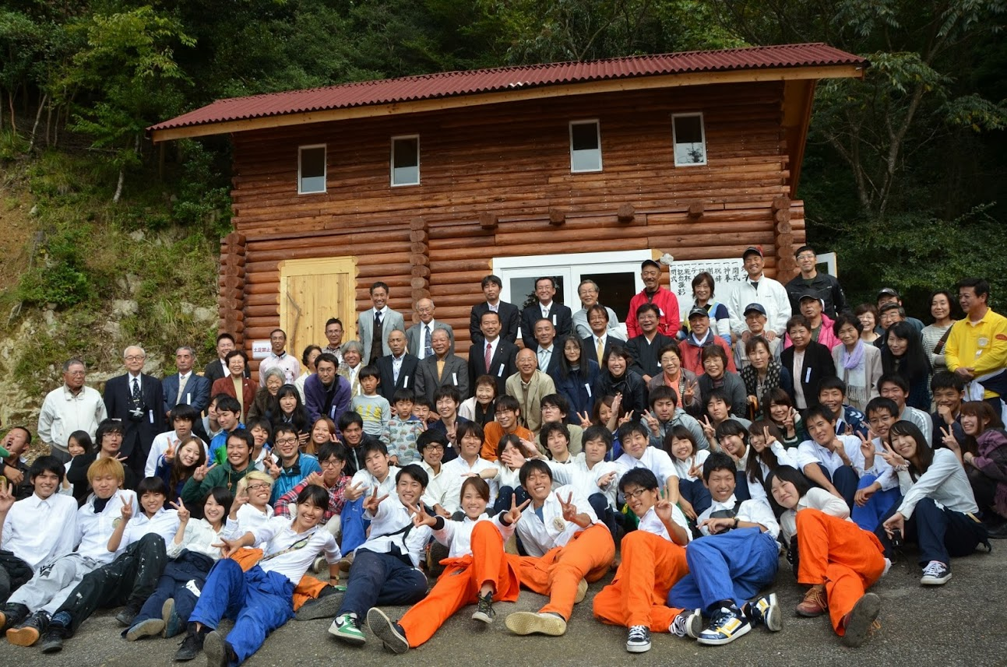
Completion Ceremony of Log House, 19, 10, 2013

These all activities are related to “the Practical Education with the Response” for our students.

